Atharv Arya

1BM18CS020

PROGRAM TITLE: GAS SENSOR

Aim: DESIGN A SMART GAS LEAKAGE INDICATOR SYSTEM (GAS SENSOR AND LED)

Hardware Required:

* Arduino Board
* LED
* Breadboard
* Gas Sensor
* 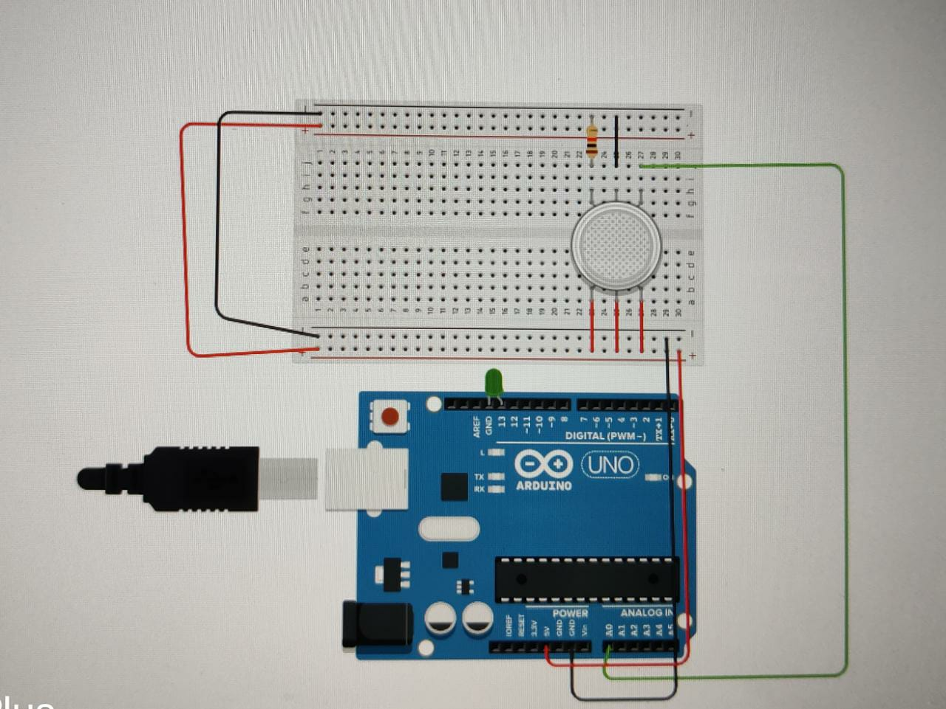Resistor Circuit Diagram:

Write-Up:

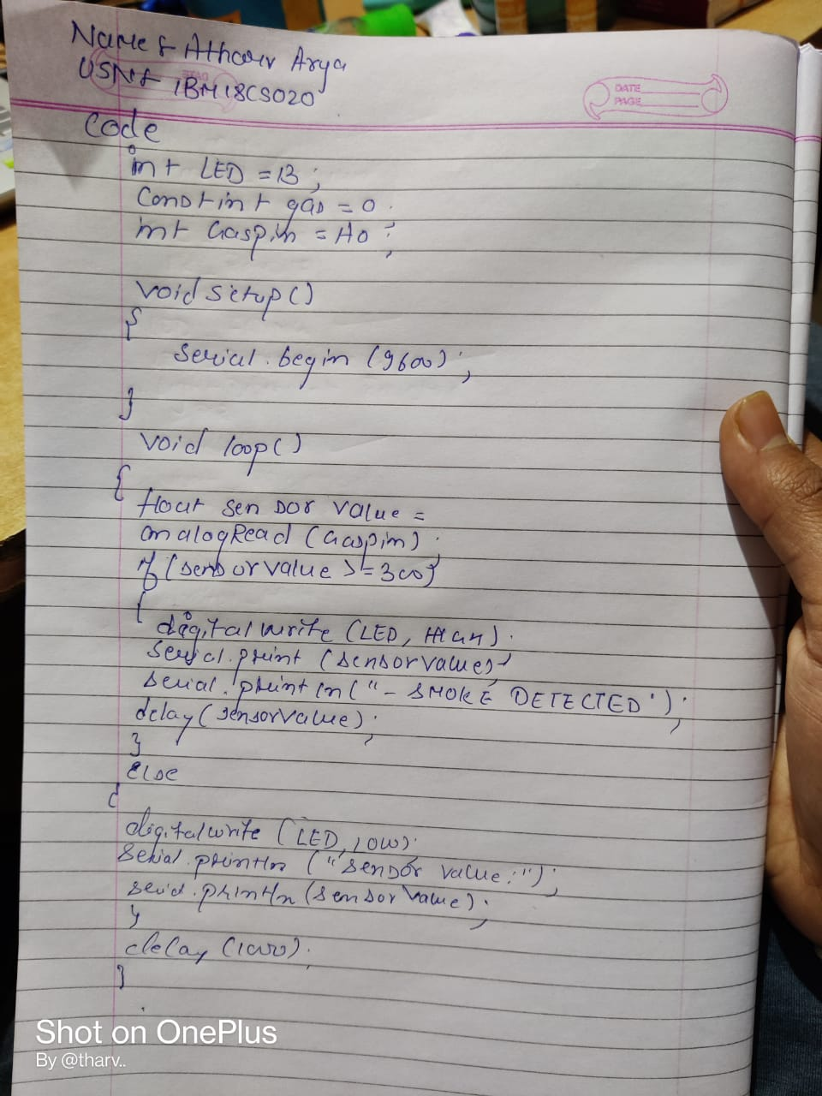

CODE:

int LED = 13; const int gas=0; int Gaspin= A0;

void setup()

{

Serial.begin(9600);

}

void loop()

{

float sensorValue = analogRead(Gaspin); if(sensorValue>=300)

{

digitalWrite(LED,HIGH); Serial.print(sensorValue); Serial.println("-SMOKE

DETECTED");

delay(sensorValue);

}

else

{

digitalWrite(LED,LOW); Serial.println("Sensor

Value: ");

Serial.println(sensorValue);

}

delay(1000);

}

OBSERVATION/OUTPUT:

The gas sensor checks whether there is a leakage or not.If yes, it displays SMOKE DETECTED otherwise it displays the sensor value.